

Infant Smart Monitoring System

Team Name: Neo | EBAC4 | 31/03/2018

[e0146864, e0146946, e0147017, e0146771] @u.nus.edu

Contents

Business Objectives 2

Project Deliverables 2

Initial Technical Strategy/Analytical/Modeling Approach 3

System Diagram 3

Data Gathering 4

Project Planning 5

Project Methodologies 6

Source Code Management 6

Project Tasks Management 6

Roles and Responsibilities 7

Resources Requirement 7

Project Deliverables and Plan (Gantt Chart) 8

Current Problems and Risks 8

Initial Analysis and Modeling 9

References 11

# Business Objectives

This is a self-driven project by Team Neo. The main business objective of this project is:

1. Build a highly accurate small size system to real time analyze/alert working parent if the child is in distress condition at home.
2. The major goal we are trying to achieve with this project is to improve the productivity of the working parents at office.

At present, it is common in Singapore to hire a Foreign domestic worker to take care of household chores and young babies. Parents normally install IP camera and intermittently keeps checking in from workplace to check the well-being of their babies. This process by default is unproductive and chances of logging/checking in the hour of need is not consistent.

Babies cry for many reasons, and crying is the main way babies communicate. It’s the way they capture attention and express their needs. Most babies will continue to cry or show that they are upset until a parent or caregiver responds to their needs.

The audio data captured in a domestic environment could be used to build a Predictive Model and predict real time to alert the parents of any condition. The system will be built with reference to a paper published [[1]](https://www.researchgate.net/publication/311011518_Baby_cry_detection_in_domestic_environment_using_deep_learning) to detect baby cries in domestic environment using Predictive Modelling techniques.

The major success criteria or the MVP of the products are defined as:

1. Successful generation of accurate alerts
2. Timely alert to the mobile devices

# Project Deliverables

We define our project deliverable as below;

*“A working Portable System which could be hosted at any place to smart monitoring the infants.”*

The above system will help parents to:

1. Setup the devise anywhere in the house within the Wi-fi network
2. Device able to analyze and predict the incoming stream of audio.
3. Device should generate successful, accurate and timely alerts.

Project will be verified as below:

1. Validating the models against actual historical data.
2. Customer feedback post alert generation

# Initial Technical Strategy/Analytical Engine/Modeling Approach

To analyze and predict the incoming stream of audio in the house where system is hosted and capable of generating successful and timely alerts, we have extracted the all possible relevant features of audio file such as MFCC, ZCR, Spectral Roll off, STE, Harmonic and Pitch and applied predictive modeling using those features as independent variables.

Initially we used the logistic regression for the prediction. In the context of Generalized Linear Model, Logistic regression analysis is often used to investigate the relationship between a Binary response outcome and a set of explanatory or independent variables. A Binary response consists either success or failure. In our case, response as success is the alert for detecting baby cry.

Also, we are not rejecting alternating approach at this moment. Neural networks are somewhat related to logistic regression. Basically, we can think of logistic regression as a 1-layer neural network. As the complexity grows in future, we will eventually move to neural network with multiple layers with different activation functions. We used neural network with three different solvers, Adam, SGD & lbfgs. Adam was better among the three solvers.

Next we used Random Forest and SVM. Random Forest was giving better results as compared to Neural network due to low volume of data. SVM gave the least accuracy as compared to the rest. Currently we partially met our business goals it can be finished by the end of project.

To summarize, we are approaching the classification problem with simple models first proceeding to complex models like Neural Network,SVM and Random Forest. .

Among the three models Neural Network gave the best result in terms of accuracy. We thereby, decided to use the deep learning models going ahead.

As we begin to see results from our preliminary output, it is extremely important to collaborate with the guiding coalition to communicate these wins. By engineering our strategy around initial short-term wins, it will help us preserve and increase buy-in. Short-term wins help us build momentum as we work towards our vision.

### System Diagram

The high-level system diagram is as below. Figure below shows the Intel Realsense Robotic development kit and a web component to register the user and connection details for alert generation.

We have built a frontend/Backend interface to decide upon if the audio is cry/no cry. We have used Twilio integrated with Python code to generate instant alerts over SMS to the registered users. We have built a web application using NodeJS/ReactJS to display data on dashboard. Overall, we have used Python, NodeJS,Javascript for building our end to end system.

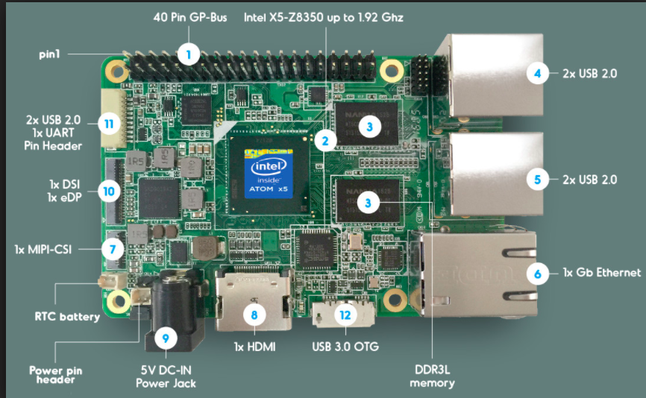

1. Registered on WIFI and mobile number
2. Deployed model on Intel Board
3. Capture real time stream
4. Predict the outcome
5. If cry -> send alert to mobile

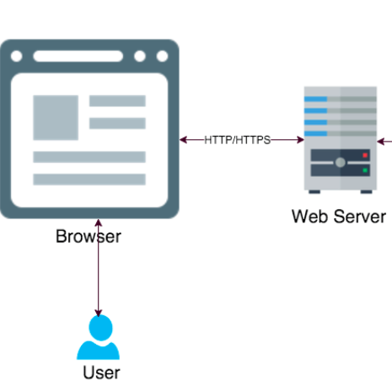

* Webpage to register mobile number, wifi username /password
* Deploy Updated trained models

### Flow Chart

Below shown is the flow chart on different component (Train the system/build classifier <left>, Deploy the System to predict for alert <right>)

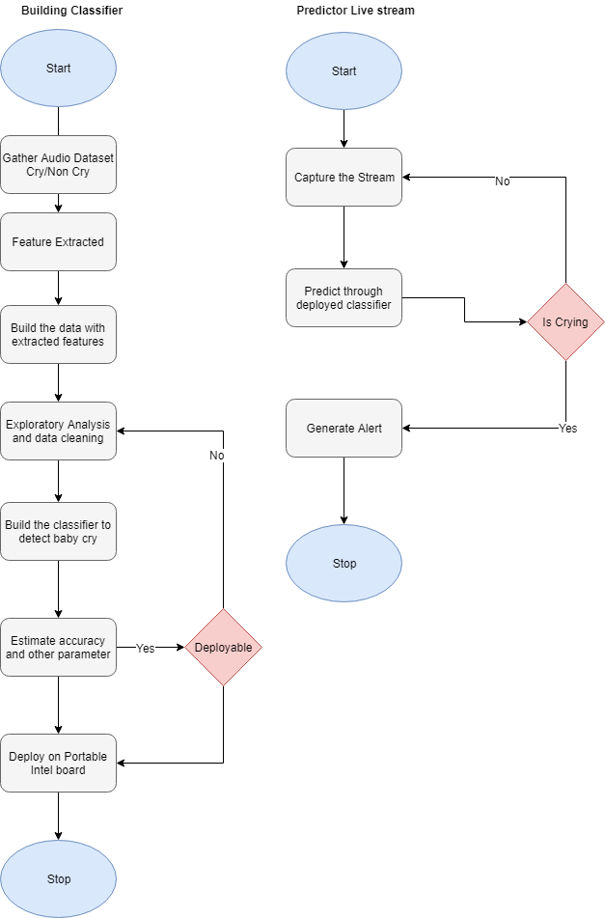

# Data Gathering

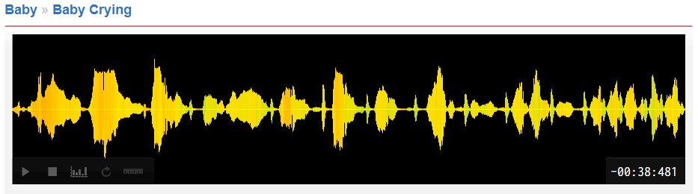

We need crying baby audio along with other environmental sounds to build model. Currently the number of observations is undefined. However we have discovered 3500observations for initial model building from open data community. We are in the process of collecting more data in order to build a more accurate model.

Once audio files are gathered it will be used to extract audio features for model building. We are using python libraries to extract these features.

Challenges

* Data gathering is critical for the project and remains a challenge
* Manual tagging of dataset into cry/no cry
* Mimicry of cry data to be tagged as non-cry

# Project Planning

High Level project release plan is divided in to three phases. The expected business objective as laid out in the briefing are as shown below:

Keeping in view all the deliverables mentioned above, the technical epics are mapped as below in all phases:

### Project Methodologies

As a team, we have agreed to adhere to follow the **Agile principles and values**. To summarize we believe in the following:

1. Individuals and Interactions over processes and tools
2. Working software over comprehensive documentation
3. Customer collaboration over contract Negotiations
4. Responding to change over following a plan

### Source Code Management

We have identified [git@Bitbucket](https://contactprad@bitbucket.org/teamneo/myhappybaby.git) as our choice of source code management. The primary reasons for this selection is because we can keep our source code private for free at bitbucket and maintain project within a small team.

### Project Tasks Management

We have identified a free open source tool to manage day to day tasks and their progress

The link for the same is as follows: <https://trello.com/b/fGF2uslm/fyp>

Below is the quick snapshot of the board.

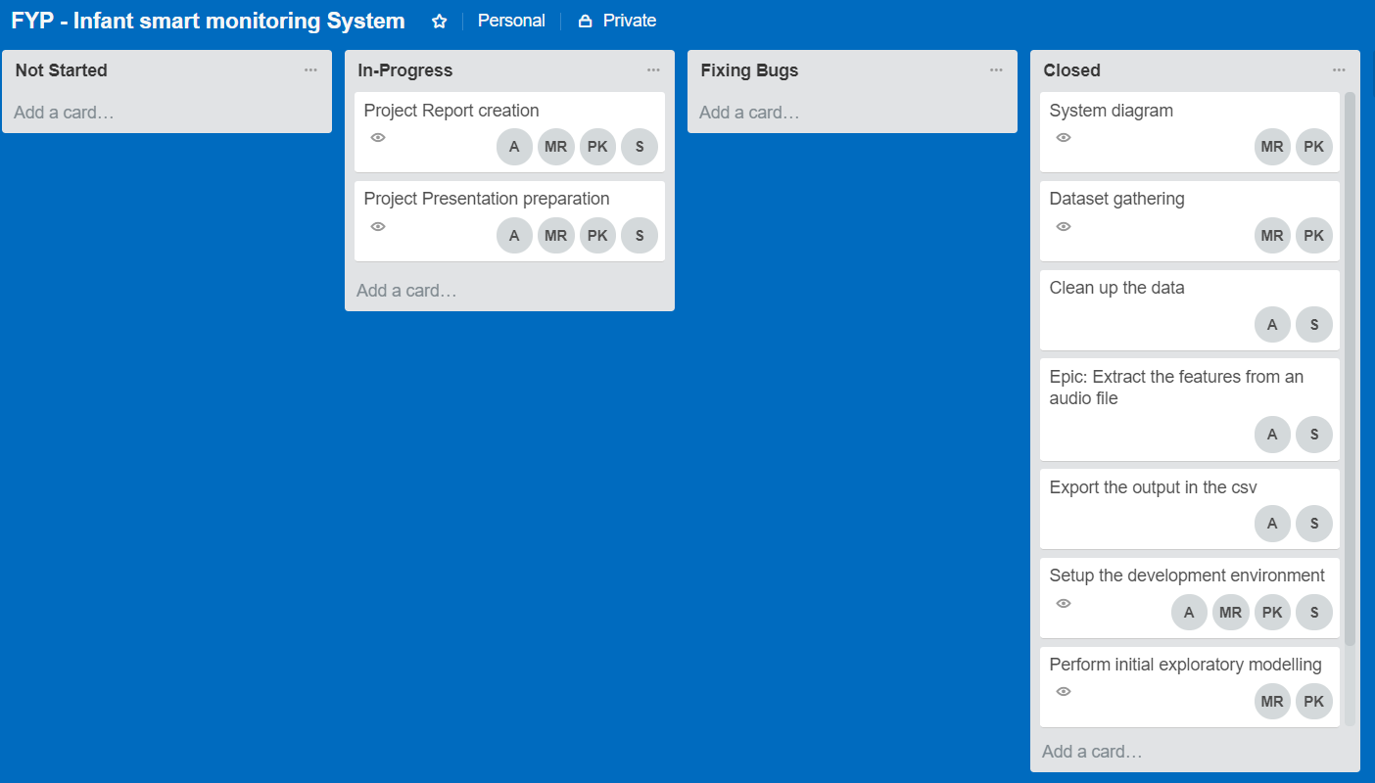

### Roles and Responsibilities

Since this is a small team group and within agile methodologies, we tend to not to differentiate in the skill set and work on the tasks and availability of the resources. We have similar role, title and responsibilities for each member. As a team, we agree to empower each member for shortage of skill in specific areas and following pair programming methods to build our system. Table below are the names of the team members and their titles:

|  |  |
| --- | --- |
| Name | Role |
| ANUSUYA MANICKAVASAGAM | Data Ninjaneer |
| kESAVAN sRIDHARAN | Data Ninjaneer |
| mUNI rANJAN | Data Ninjaneer |
| pRADEEP kUMAR | Data Ninjaneer |

### Resources Requirement

We anticipate the requirement for following devices:

1. Intel Real sense Robotic Development Kit
2. Microphone
3. Web Camera (Non MVP)

### Project Deliverables and Plan (Gantt Chart)

The project plan report captured in Gantt Pro online is shown as below group by weeks and resources respectively:

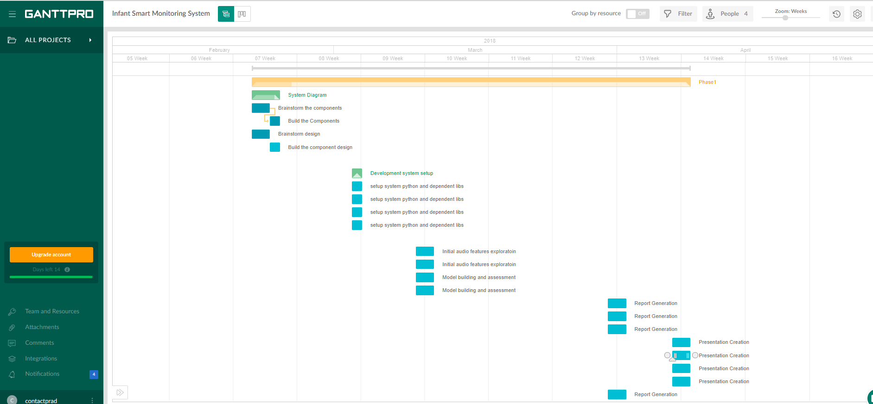

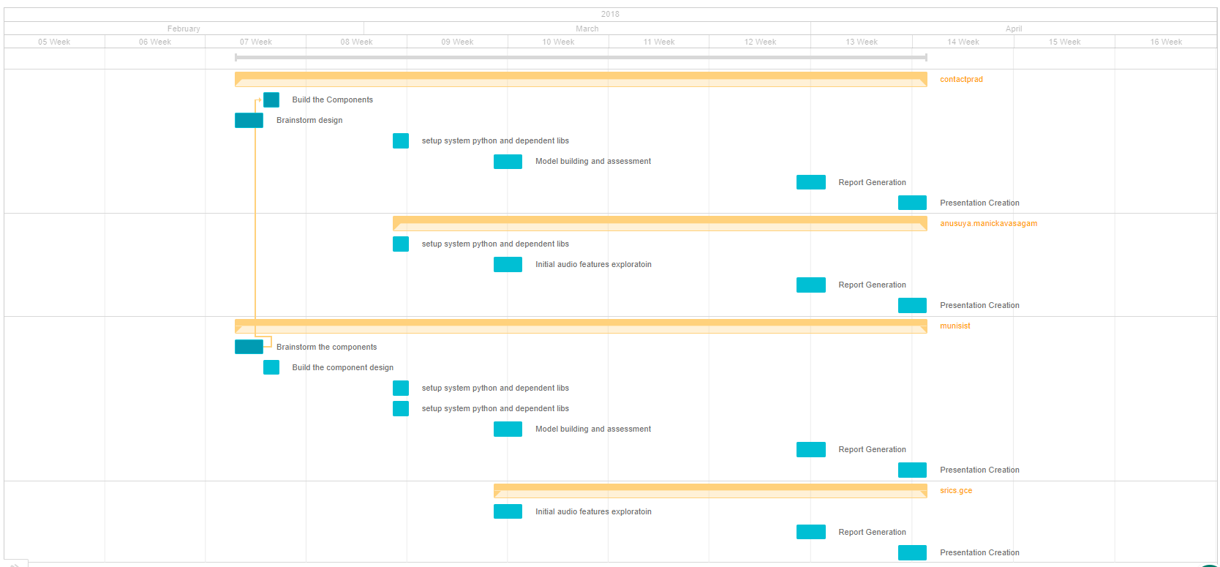

# Current Problems and Risks

We have gathered the sound audio files and done Neural Network, SVM and Random Forest models. The challenge that we are currently facing is:

* **Dataset findings**: We were able to find only limited dataset for audio files which were pre-classified into crying audio files. We also dataset for which we did a manual tagging of cry/no cry. Going ahead when we use deep learning models, we will need more data to do accurate predictions.

Required action

In order to mitigate the problems/issues we might face in future we decided to look at the risk items.

* The first item that we foresee as a risk item is timely alert generation. After classifying the audio files as crying sounds and other, we need to send alerts on a timely fashion to the parents. However, the creation of alert messages without adequate delay will make our system very useful for the parents, which can be challenging.
* Secondly, we want to deploy system on Intel board (or Raspberry pi) in the future. Also, we want to change the platform from Windows to Ubuntu. Making our system workable and successful on an integrated system would be challenging.
* Thirdly, when we deploy the system in a workable environment, we also foresee privacy concerns of the users who use the system. As we are focused on gathering the features of baby crying, we need to see if the system will pick up crying of adults (or non-babies), thereby giving rise to privacy concerns.

But, as of now, we do not see these problems arising. We will intimate ISS (or request for help) in case of any risk situation.

# Initial Analysis and Modeling

The initial analysis we have done on the audio files was mainly focused on feature extraction of the audio files. We have taken **“2016 ICSEE International Conference on the Science of Electrical Engineering”** paper, “**Baby Cry Detection in Domestic Environment using Deep Learning**” and extracted audio features like ZCR, STE, Spectral Roll off, MCFF, Harmonic and Pitch using various libraries in Python.

The audio features extracted were all in numerical format. Since, we needed to do a classification of audio files we decided to do visual and numerical analysis of the input audio features extracted. We have done visual exploratory checks by observing the **histogram** and the **box plot graphs** on the input data (audio features). We have also done numerical analysis by observing the various descriptive statistics. We have identified 31 missing values and 4 outliers out of 2000 observations. We performed data cleaning which improved the overall performance of the model.

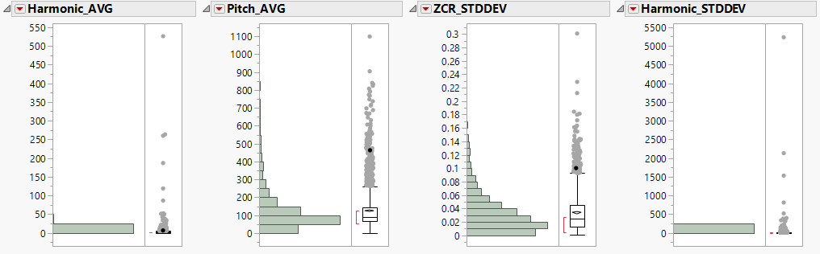

We built our analytical Engine using models such as Neural Network, SVM and Random Forest.The results are as below:

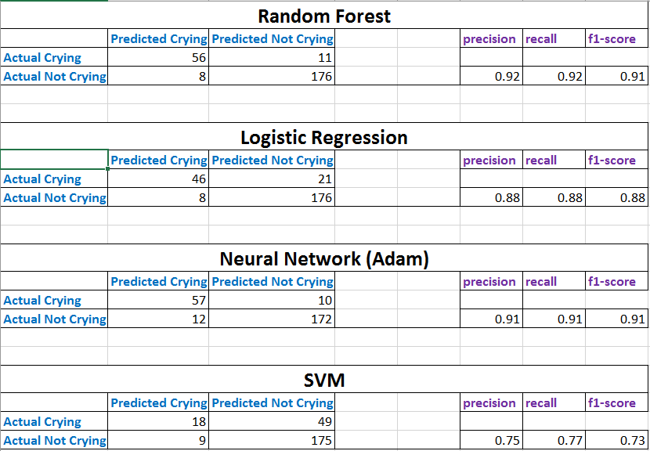

We are in the process of extracting more datasets (containing primarily baby crying and other audio) which would enable us to make accurate prediction

## References

1. <https://www.helpguide.org/articles/parenting-family/when-your-baby-wont-stop-crying.htm>
2. <https://www.researchgate.net/publication/311011518_Baby_cry_detection_in_domestic_environment_using_deep_learning>
3. <https://ganttpro.com>
4. <https://trello.com/b/fGF2uslm/fyp-infant-smart-monitoring-system>
5. <https://drive.google.com/drive/folders/1UAZwY_wk0s1oI0Od1-WX_ilWTzm9E1Eg?usp=sharing>